The functions of Platinum International Talent Card
I
In order to retain the key industry international talent in Taiwan, the Ministry of Economic Affairs issues the multi-functional “International Talent Card”. InvesTaiwan Service Center coordinates the resources from government agencies to provide international talent with value-added services. The function of the Platinum Card includes speedy immigration clearance for the cardholders along with spouses or lineal relatives traveling with them. Besides, the functions include EasyCards, APP, and QR Code, in order to provide the information regarding on living, education, entertainment, and tourism. This will help us provide a better and friendlier living environment for international talent in Taiwan.
善
Application Steps
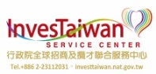
Applicant

■ EasyCard
■ Speedy Immigration Clearance
■ Value-Added Services- Special Events、QR Code
■ Administrative Services - Free Legal Consultation & Information on living, entertainment, and tourism in multiple languages
(From applying for the Card to sending the card: 1 month)
Applicant
Fill in the application form & submit the required documents
Recommended Organization
Fill in the recommendation letter & submit the required documents

Recommended Organization
Chamber of commerce, industry association, juridical body, or government agency
Sending the Card
Reviewed & Result of the review —
Examination Committee,
Industrial Development Bureau

Pass the Examination
Inform:
Recommended Organization & Applicant
InvestTaiwan
Service Center
(Accept applications &
Preliminary examination

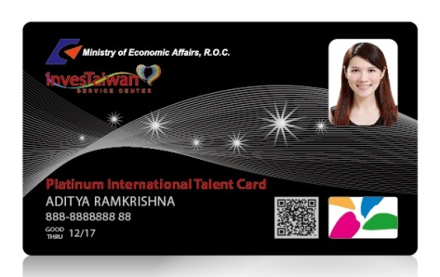

The Applicant Qualifications
II
Application Requirements | The managerial and other high-level international personnel in addition to being involved in one of the Ten Key Industries or key-technology products and R&D, marketing, and customer management, and having obtained work permits, must comply with one of the following conditions:  - Having at least five years of work experience in his or her field, with outstanding accomplishments in industrial technology, or having made contributions to Taiwan’s industry or economy, having developed industrial technology that enables substantive industrial upgrading in the Taiwan area.  - Having won award(s) in major domestic or overseas entrepreneurship or design competition(s), or holding an Entrepreneur Visa.
Recommended Organization | Chamber of commerce, industry association, juridical body, or government agency | Competent agencies for target industries of the Central Government
Industry | Ten Key Industries  - Industry 4.0  - Advanced Manufacturing Equipment  - Advanced Electronics (including IC Design and Semiconductor Manufacturing)  - Integrated Application of Smart Systems (including Big Data, Internet of Things, and Cloud Services)  - 5G & Advanced Communications  - Biomedicine & Medical Devices  - Renewable Energy  - Design of Innovative Products & User Experience  - Advanced Technologies & Innovations  - International Financial Services | Not involve in the Ten Key Industries  Cultural, social, educational, and service industry

Applications for Platinum International Talent Cards are accepted on 28th, April, 2016. If you are interested in applying for the card, we cordially welcome you to submit the application by a chamber of commerce, industry association, juridical body, or government agency. Please kindly contact us if you need the related association’s recommendation by the assistance from our center.
a one-stop service center providing customized services to investors
Investment / Recruitment
行政院全球招商及攬才聯合服務中心
TEL： 02-2311-2070 02-2311-2170
ADDRESS：台北市中正區襄陽路1號8樓
E-MAIL： recruit@invest.org.tw

